Top 20 Pages Report

This report uses information stored in the Interaction tables to display the 20 pages with the most views. This example defaults to the past 30 days and looks at total views. Filters allow you to easily change those parameters to a different date range and number of unique views.

Prerequisites:
- Log Page Views must be turned on for the site you are reporting on. From the menu select Admin Tools > CMS Configuration > Sites. Select the site and click edit. Make sure “Log Page Views” is checked in the Advanced Settings section.
Instructions:
- Create a new page in Rock for this report.
- Add two blocks to the new page
  - Page Parameter Filter
  - Dynamic Data
- Edit the Block settings of the Page Parameter Filter. Set the desired “Filter Settings” and add the following filters:
  - Name: Start Date, Key: StartDate, Field Type: Date
  - Name: End Date, Key: EndDate, Field Type: Date
  - Name: Views, Key: Views, Field Type: Single-Select, Values: Total, Unique
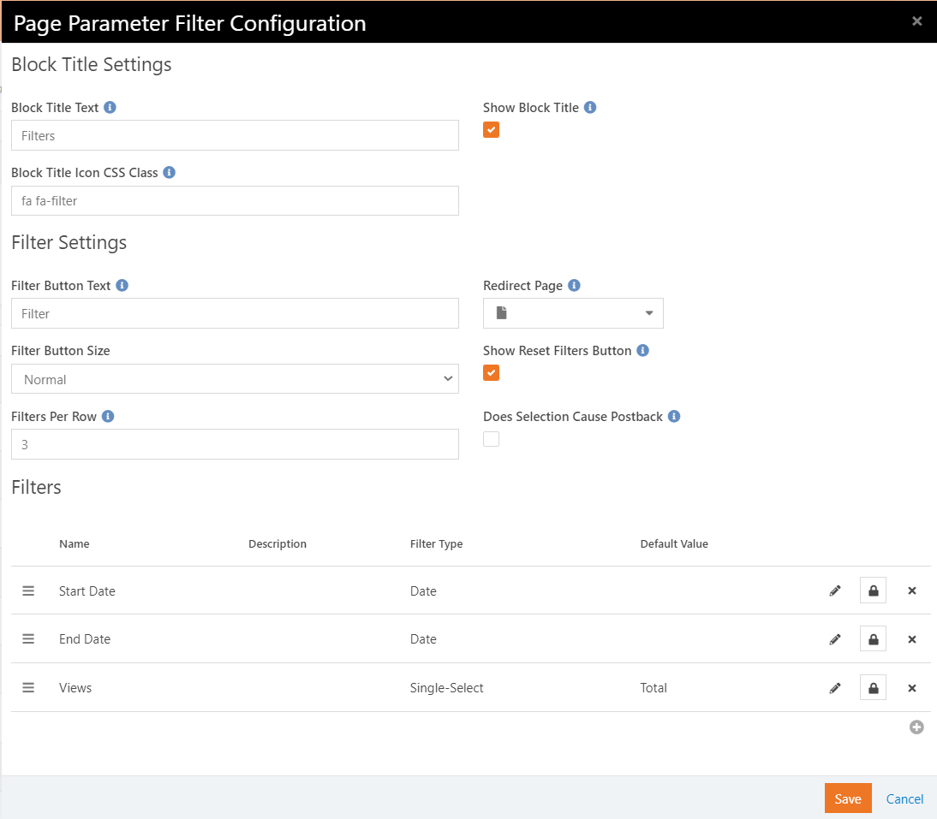
- Edit the Block settings of the Dynamic Data Block. Copy and paste the following into the Query box:
/* Assign variables a value from Page Parameter Filters. */
{% assign startdate = 'Global' | PageParameter:'StartDate' | Date:'M/dd/yyyy hh:mm' %}
{% assign enddate = 'Global' | PageParameter:'EndDate' | Date:'M/dd/yyyy hh:mm' %}
{% assign viewsMode = 'Global' | PageParameter:'Views' %}
/* Assign default values if no Page Parameter Filters are blank*/
{% if startdate == '' %}
{% assign startdate = 'Now' | DateAdd:-30,'d' %}
{% endif %}
{% if enddate == '' %}
{% assign enddate = 'Now' | Date:'M/d/yyyy'%}
{% endif %}
{% if viewsMode =='' %}
{% assign viewsMode = 'Total' %}
{% endif %}

SELECT
TOP 20 icomp.[Name], i.[InteractionSummary], count( {% if viewsMode == 'Unique' %}DISTINCT{% endif %} inse.[IpAddress]) AS ViewsAmt
FROM
[Interaction] i
INNER JOIN [InteractionSession] inse ON inse.[Id] = i.[InteractionSessionId]
INNER JOIN [InteractionComponent] icomp ON icomp.Id = i.InteractionComponentId
INNER JOIN [InteractionChannel] ichan ON ichan.Id = icomp.InteractionChannelId
WHERE
[InteractionDateTime] >= '{{ startdate }}'
AND [InteractionDateTime] <= '{{enddate}}'
AND [Operation] = 'View'
AND ichan.ChannelEntityId = 10
GROUP BY
icomp.[Name], i.[InteractionSummary]
ORDER BY
ViewsAmt DESC

- Modify the ChannelEntityId selection criteria (5th line from the bottom) to use your site id.

- If you would like each grid line to link to the actual website page, set the Selection URL to {InteractionData}.

- Click Save and your page should look like this:

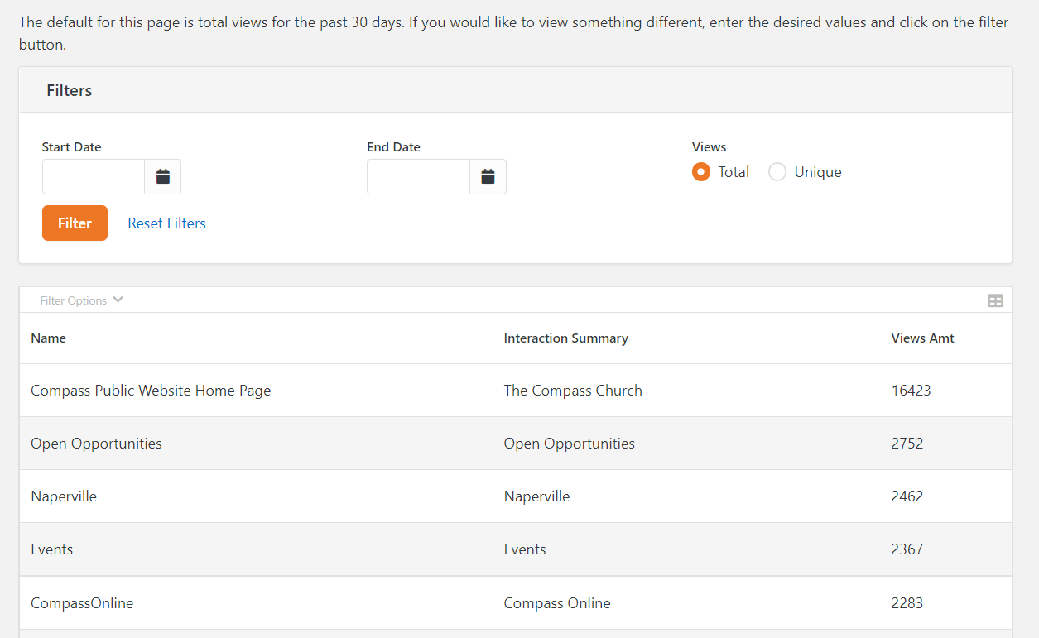

Unsubscribe Reporting

Use this SQL to find the communications generating the most unsubscribes. Optional – filter on the InteractionDateTime field to find unsubscribes during a certain time frame.
SQL
SELECT C.Id, C.Name, COUNT(I.Id) AS Count
FROM [Interaction] I
JOIN CommunicationRecipient CR ON I.EntityId = CR.Id
JOIN Communication C ON CR.CommunicationId = C.Id
WHERE I.Operation = 'Unsubscribe'
GROUP BY C.Id, C.Name
ORDER BY Count DESC

Sample Results
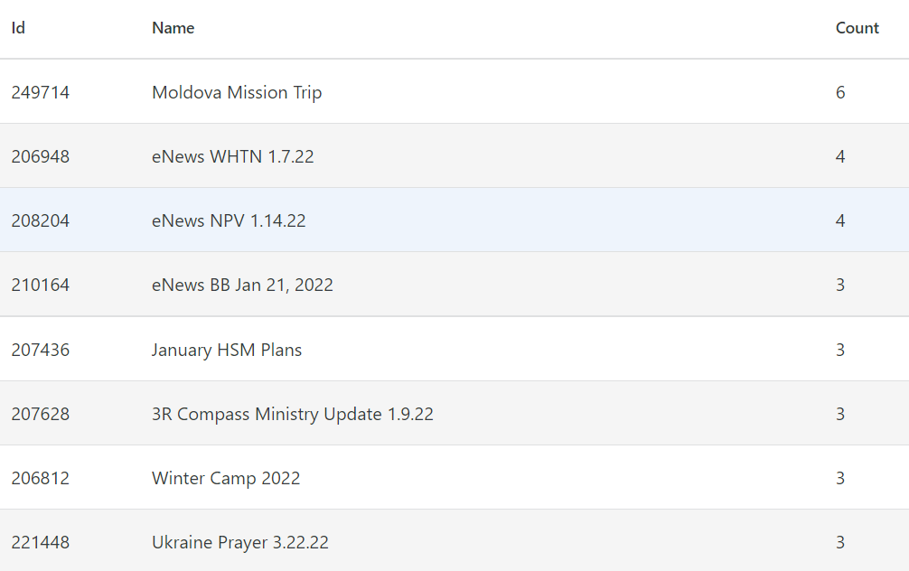
Device Type Metric

Create a metric to track the types of devices viewing your website. Use the Pie Chart block to display the metric results on a page.
Metric Instructions:
- Create a new metric in Rock to track Desktop devices.
- Set the Title to “Desktop Views” or something similar.
- Set the Source Type to SQL.
- Copy and paste the following into the Source SQL box
{% assign date = RunDateTime | DateAdd:-1,'d' %}
SELECT COUNT(DISTINCT S.Id),'{{ date }}' [MetricValueDateTime]
FROM [Interaction] I
JOIN InteractionSession S ON I.InteractionSessionId = S.Id
JOIN InteractionDeviceType D ON S.DeviceTypeId = D.Id
JOIN InteractionComponent C ON I.InteractionComponentId = C.Id
WHERE CAST(I.InteractionDateTime AS DATE) = '{{ date }}'
AND Operation = 'View'
AND D.ClientType = 'Desktop'
AND C.InteractionChannelId = 11

- Edit the last line to reflect the Interaction Channel Id of your website.
- Set the schedule. The above code assumes you are collecting this metric every day for the previous day. If you choose a different schedule, you will have to modify the logic.
- Click Save.
- Repeat steps 1-7 for Mobile Devices. Modify the Client Type statement to read “AND D.ClientType = ‘Mobile’.
- Repeat steps 1-7 for Tablet Devices. Modify the Client Type statement to read “AND D.ClientType = ‘Tablet’.

Chart Instructions:
- Add the Pie Chart block to a page in Rock
- Modify the block settings as follows:
  - Name: “Devices Pie Chart” or something similar
  - Title/Subtitle: In my example I used “Device Types/Previous 7 Days”. These are optional fields that you can populate as you would like.
  - Column Width: 3 for this example.
  - Chart Style: I used Rock for this example.
  - Series Partition: Entity Type should be blank.
  - Metrics: Select the three metrics we created in the previous section.
  - Metric Value Type: Measure
  - Date Range: Previous 7 Days unless you prefer something different.
  - Detail Page: Blank in this example
- Click Save
- Refresh the page and your chart should look like this:

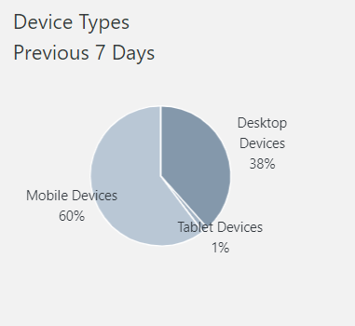

Links from Facebook

Use this SQL to find the number of links that came from Facebook. In the first example, interactions are grouped by the page component. The Event Details page receives the most links, but you do not know which event. The second example includes the Interaction Summary which includes the event name. Modify the date selection as needed.
Example 1 SQL – Grouped by Page
SELECT IC.Name, COUNT (I.Id) AS Clicks
FROM [Interaction] I
JOIN InteractionComponent IC ON I.InteractionComponentId = IC.Id
WHERE InteractionDateTime >= '1/1/2022'
AND Operation = 'View'
AND InteractionData LIKE '%fbclid%'
GROUP BY IC.Name
ORDER BY Clicks DESC

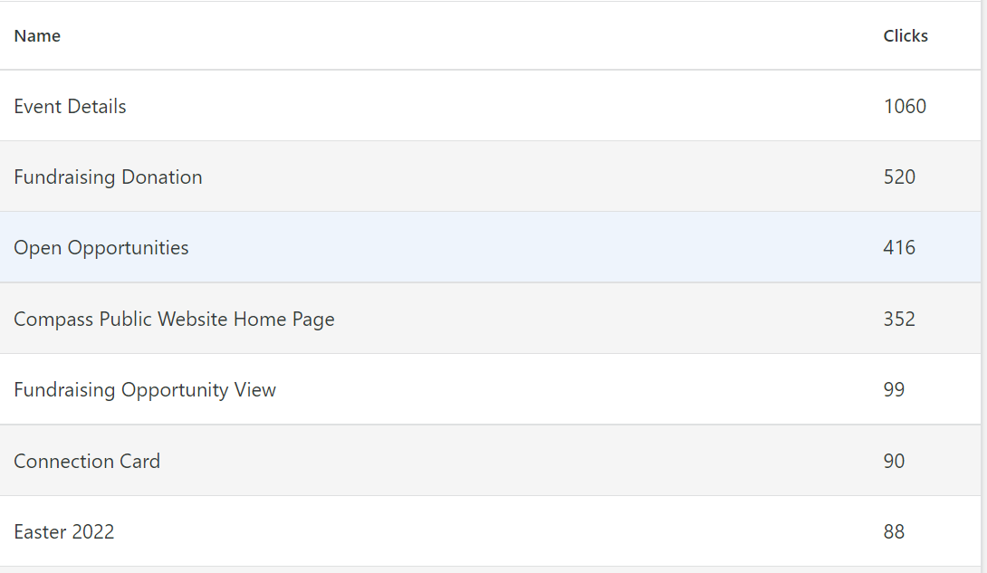
Example 1 SQL – Grouped by Page
SELECT I.InteractionSummary, IC.Name, COUNT (I.Id) AS Clicks
FROM [Interaction] I
JOIN InteractionComponent IC ON I.InteractionComponentId = IC.Id
WHERE InteractionDateTime >= '1/1/2022'
AND Operation = 'View'
AND InteractionData LIKE '%fbclid%'
GROUP BY I.InteractionSummary, IC.Name
ORDER BY Clicks DESC

